Overview

Additional resources

Need more help?

Check the resources, and then see Ken

Main content

**How to Run a Mechanics Experiment**

1. Fill an ice-bucket (with ice…).
2. Get a clean glass Petri dish, half-fill it (~30 ml) with Relax and put it on ice.
3. Take a fiber bundle (stored in Glycerol Relax in the -20C freezer) and place it in the Petri dish. (Make sure it is fully submerged).
4. Make sure the motor is clear of the force transducer and any potential obstruction. Switch it on and check the output voltage is close to zero volts.
5. Switch on the force transducer, check the output voltage is between 0V and ~-0.6 V.
6. Fill chamber B (the one next to the very large chamber, see later diagram) with Relax (~340 µl if you are using the Wildcat setup).
7. Position the force transducer and the motor arms in chamber B and put three floss loops on each arm.
8. Cut the fiber bundle free from the thread loops and pull one fiber free from the bundle. Have a very a close look at the fiber - if it is kinked, or nicked, pull another fiber - repeat until you have a fiber that is 'clean', straight and (as far as you can tell) uniform.
9. Carry the fiber across to the second chamber on your forceps (get the fiber floating, come up underneath the fiber with closed forceps, lift it up clear of the dish, move across to the setup and immerse the fiber in Chamber B, now carefully open your forceps - if it's stuck, drape over the force transducer or motor trough and gradually work it clear).

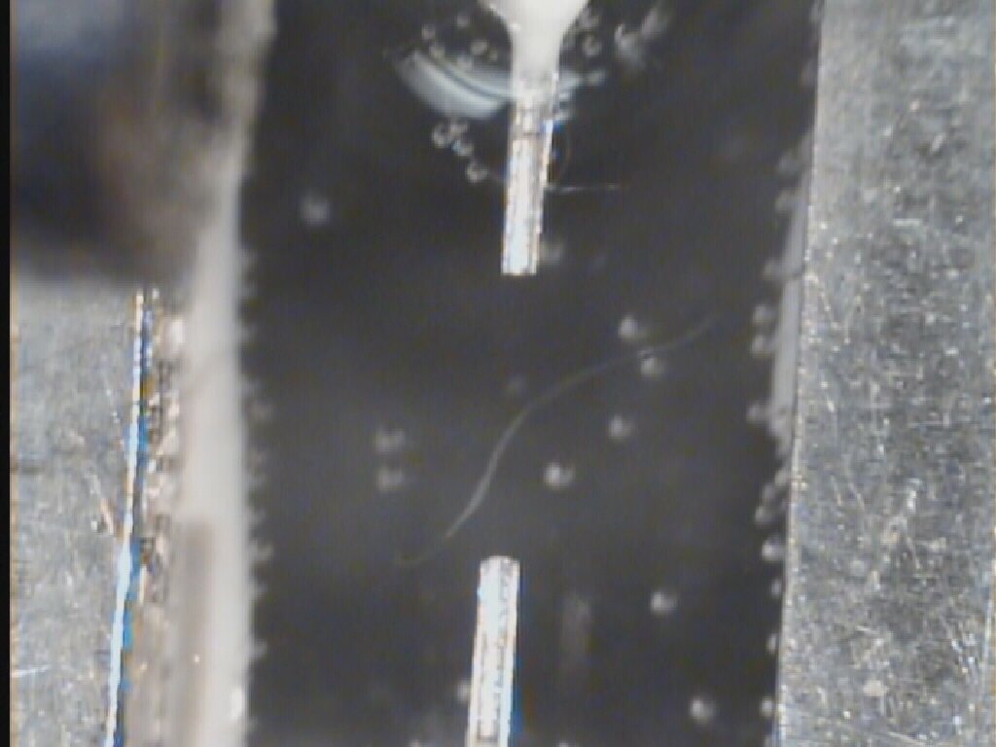

1. Tie in (this may take a few hours or so at the beginning). You will find it easier to work near the surface of the Relax though be careful not to have the fiber out of the solution.
   1. first place one end of the fiber in the force transducer trough and the other end in the motor trough.
   2. Now place one 'pin' over the fiber in the back of the force transducer trough (i.e. the bit furthest away from the motor), pull a floss loop over the pin and tie. Keep the knot on the underside. Repeat for the motor trough.

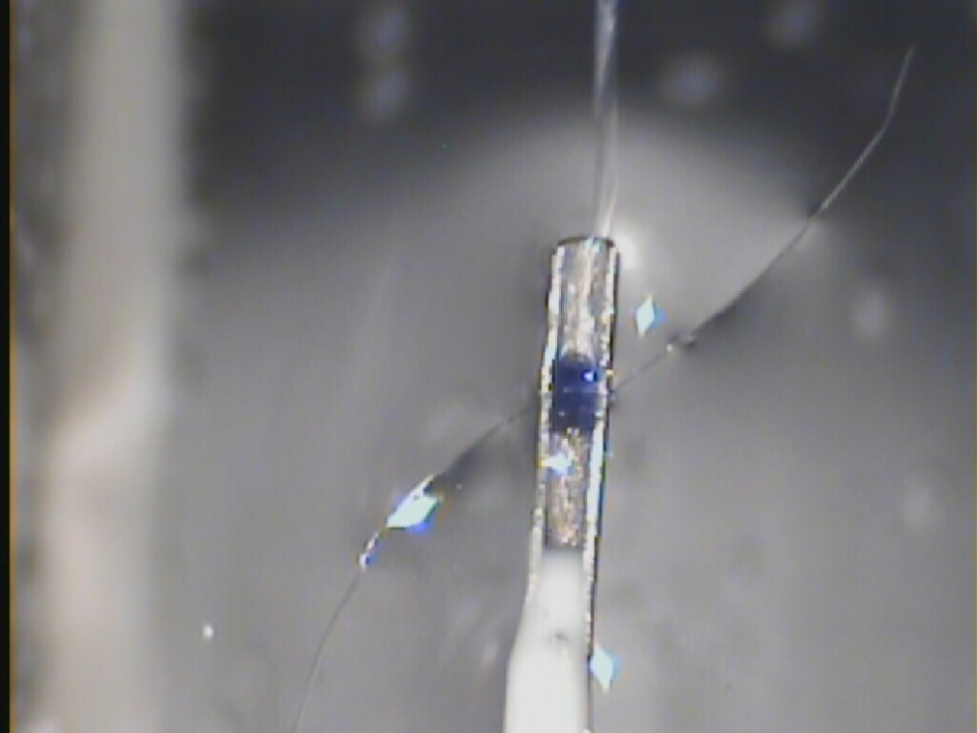

* 1. Now place a second pin in each trough, positioned so that the pin is flush with the front of the trough. Secure with 2 loops on each pin, knots on the underside. Try to make sure the loops are tight ('sinch' down by very gentle tugs) and that the second loop is as close as possible to the end of the trough. Be aware that it is very easy to pull the second loop off the trough in which case you nearly always tourniquet the fiber.

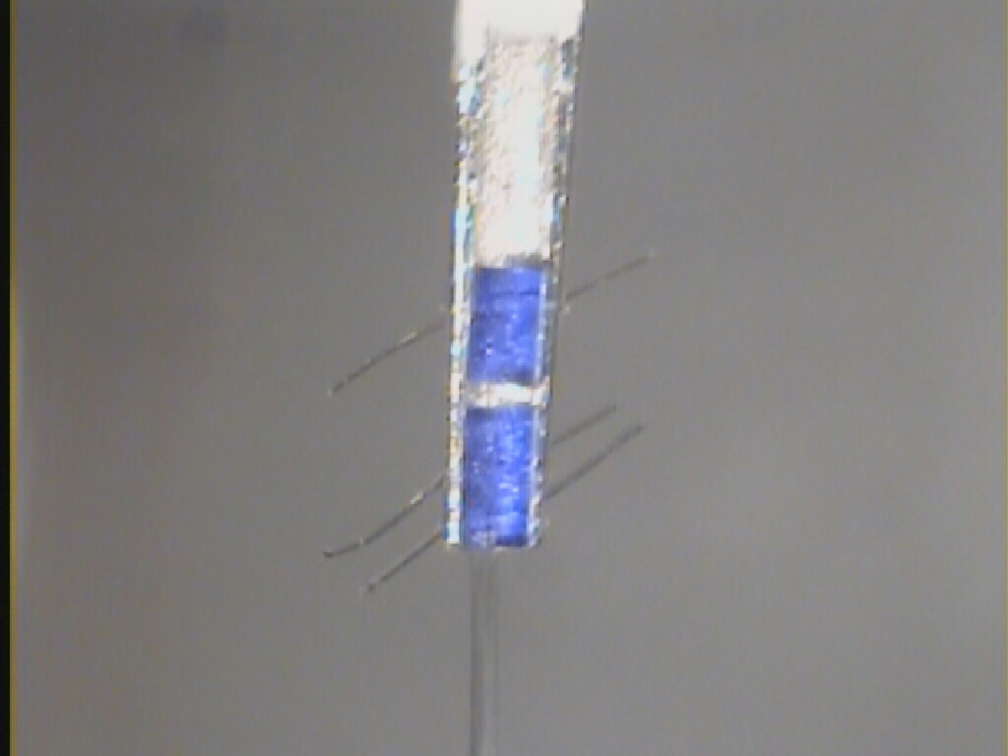

1. Lower the fiber a few millimeters into the solution, perhaps a third of a way down the chamber.

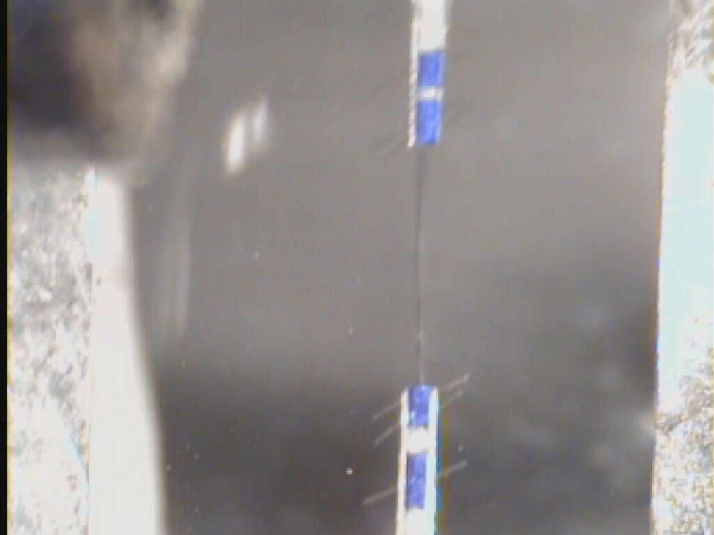

1. Move the stage to the microscope. Plug in the power supply and the Peltier wires. Turn on the water and the Peltier power supply (one switch does all).
2. Keep cooling until Chamber D (see later diagram) gets to 15°C.
3. Using the *motor's* XYZ manipulator (not the force transducer manipulator) , adjust the height of the motor until the motor and force transducer are both at the same height (judged by microscope focus). Now adjust the muscle length (with the motor manipulator) until the fiber is just taught (don't overstretch).

Use the Thorlab camera to find SL, FL and Cross-section area

Use TV monitor to find SL, FL and Cross-section area:

1. Start up the TV program and the Matlab program (SLCalculation). Take a picture of the fiber, load it into Matlab and measure sarcomere length. Keep adjusting the motor manipulator until sarcomere length is between 2.55 and 2.65 µm for skeletal fibers and 2.25 and 2.35 µm for cardiac preps
2. Note the sarcomere length, now measure the fiber length (the distance between the motor and the force transducer) and the average width of the preparation (4 or 5 places along the fiber length). Calculate the cross-sectional area of the preparation assuming a circular profile i.e. Area = p.r2 where r is the radius (half the diameter). It's easiest to convert the radius to meters first.
3. Go to Windows Explorer (not Internet Explorer) and make a new directory: c:\lab\data*your_name*\*muscle_type*\*month_year*\*ddmonyy* where you fill the italics spaces with the appropriate information. For an experiment conducted on the 23rd October, 2005, *ddmonyy* would be 23Oct05. If this is the second preparation you are using that day, use 23Oct05b, the third preparation, 23Oct05c etc.
4. Start SLControl. Go Experiments‑>SL_SREC. You should get 4 windows, the top left one will look like this.

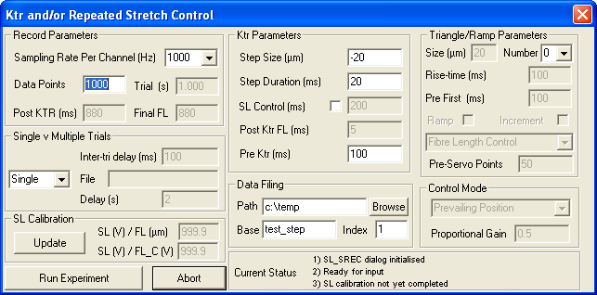

         Sampling rate per channel:              _____________

              Data points:                                 _____________

              Step Size:                                    -20% of the muscle length in microns

(MUST be negative)

              Pre Ktr:                                    _____________

              Path:                                      The new directory you've just created

              Base:                                     _____________

              Other parameters:

1. The Calibration window looks like this:

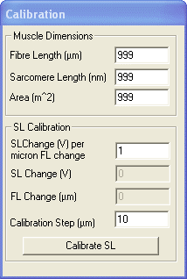

Fill in the fiber length (typically ~1000 µm), the sarcomere length (typically 2300 nm for cardiac or 2600 nm for skeletal) and area (typically in the range 3 × 10-9 to 5 × 10-8 m2, enter as 3e-8, or 3e-9 respectively).

1. At this point, let's label the chambers.

A

**B**

C

D

E

1. The fiber should currently be in Chamber B. Fill Chamber C with Relax, wait 60 s for the temperature to stabilize, move the fiber into C. Suck B dry. Fill B with pCa 9.0 solution. Wait 60 s, move the fiber back into B. Suck C dry, fill C with pre-act. Fill D with pCa 4.5 solution.
2. Check you have your parameters right. Run an experiment in pCa 9.0 solution by pressing "Run Experiment". Check traces look appropriate.
3. Now start the chart recorder running. Move the fiber into pCa 4.5 solution, wait for tension to reach a plateau, and run an experiment. Once the experiment has finished, move the fiber back into pCa 9.0 solution. Check the traces.
4. Go Analysis‑>Single Data File. Open up the pCa 4.5 file (it should have an index of 2). Check the isometric tension. Typical values are: skeletal fibers, 100 kN m‑2, cardiac 20 kN m‑2. Now fit the ktr. Place one cursor at the lowest force value following re-stretch and the other cursor somewhere near the beginning of the plateau. Press "Fit" in the "Fit Control" Window. p1 is the ktr value, typically 12 s‑1 for rat cardiac, 15 s-1 for rat psoas and 4 s‑1 for rat soleus.
5. Suck pCa 4.5 out of D, replace with a pCa value randomly chosen between 6.5 and 5.4. Wait 60 s. Move the fiber into pre-act (Chamber C). Wait 45 s. Move the fiber into D, wait for tension to plateau and run the experiment. Once the experiment has finished, return to pCa 9.0 (B). Write down the isometric tension. Plot the value on a graph (with pencil and paper…) of isometric tension against pCa.
6. Repeat 24 with different pCa values until you have completed a full tension pCa curve. This typically takes between 30 and 45 minutes (more when you are starting).
7. Once you are finished the experiment, tidy up. Move the stage back to the table, detach the fiber, remove all the floss loops etc. Wash the motor trough with distilled water (use a pipette and be careful not to spray water into the motor - *very bad*), move the motor clear of the force transducer and switch everything off.
8. Back up the data.